

Menna Elminshawy

20217011



**Assignment 3**

**Using the Geo database of Egypt located in (Egypt.mdb); each student should select the 3 layers (shykha, secall & gov). This geo database has only 27 governorates**

**Suppose we have 29 governorates because 6October and Helwan governorates will be generated**

**Edit and generate a new shape file for the governorates in Egypt which contain 29 governorates (you must add 6October and Helwan governorate) in your geo database. Where:**

|  |  |
| --- | --- |
| Gov_name | District_name |
| 6 أكتوبر | مركز الجيزة |
| 6 أكتوبر | قسم الحوامدية |
| 6 أكتوبر | مركز البدرشين |
| 6 أكتوبر | مركز العياط |
| 6 أكتوبر | مركز إمبابة |
| 6 أكتوبر | قسم الواحات البحرية |
| 6 أكتوبر | مركز أوسيم |
| 6 أكتوبر | قسم الشيخ زايد |
| 6 أكتوبر | قسم أول 6 أكتوبر |
| 6 أكتوبر | مركز كرداسة |
| 6 أكتوبر | قسم ثان 6 أكتوبر |
| حلوان | قسم ثان القاهرة الجديدة |
| حلوان | قسم المعادي |
| حلوان | قسم 15 مايو |
| حلوان | قسم حلوان |
| حلوان | قسم الشروق |
| حلوان | قسم طره |
| حلوان | قسم ثالث القاهرة الجديدة |
| حلوان | قسم التبين |
| حلوان | مركز أطفيح |
| حلوان | مركز الصف |
| حلوان | قسم أول القاهرة الجديدة |
| حلوان | قسم بدر |
|  |  |

1. **Specify your purpose of the assignment and how the selected layers will help you achieving it?**
2. **Create different types of all necessary graphs and reports that can serve the purpose of your assignment.**

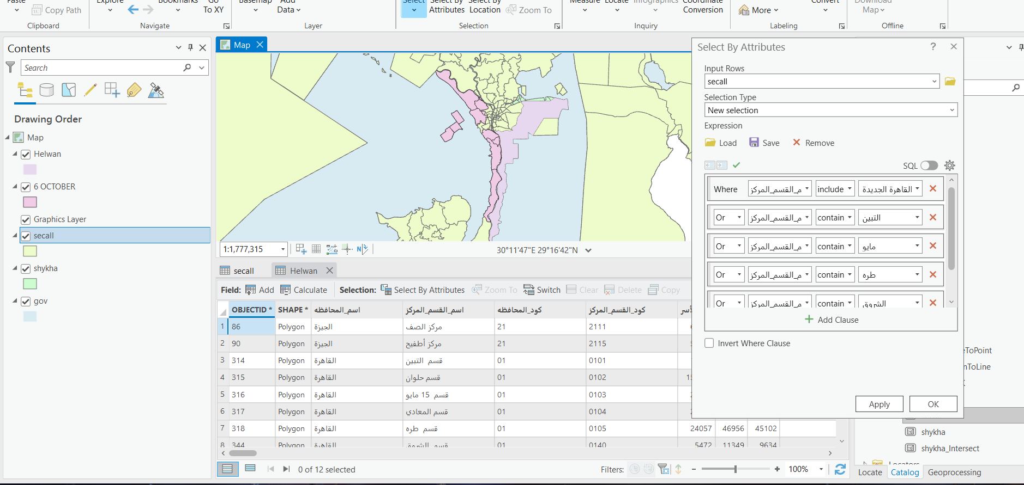

1. A screenshot of a computer

   Description automatically generatedA screenshot of a computer

   Description automatically generated

1. **Adding Legend, Scale bar, North arrow, and other textual information that can make the map more readable.**
2. **You can add anything else you see that it will be useful for your assignment.**
3. **Export your images in JPEG format with resolution 700dpi after putting all map components (verbal scale- north arrow – legend- date of production-Inset and locator map-Neat line-projection-and cartographer)**

